**Screen Design Initial Drafts**

* **Welcome/Home Screen:**

1. Pratyush -> ADR: complex vs simplistic choices

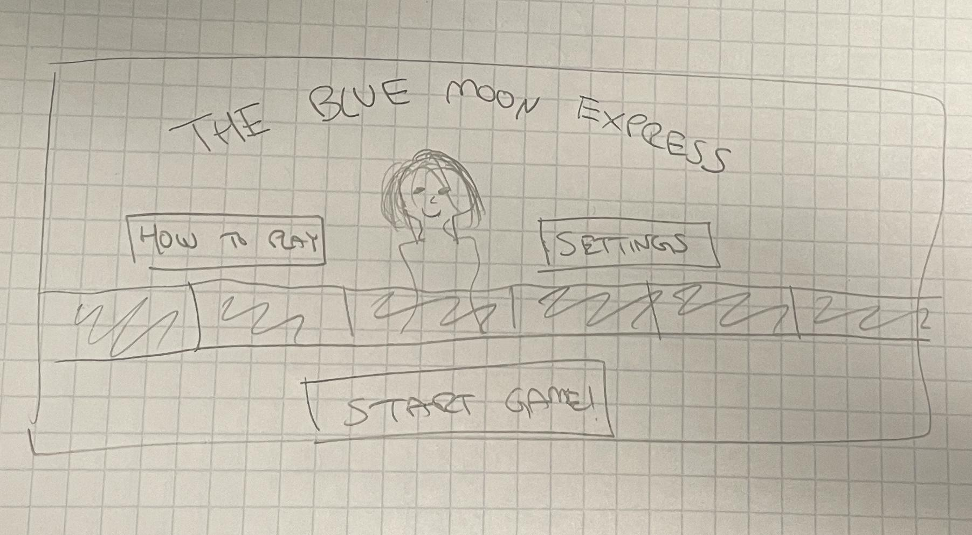

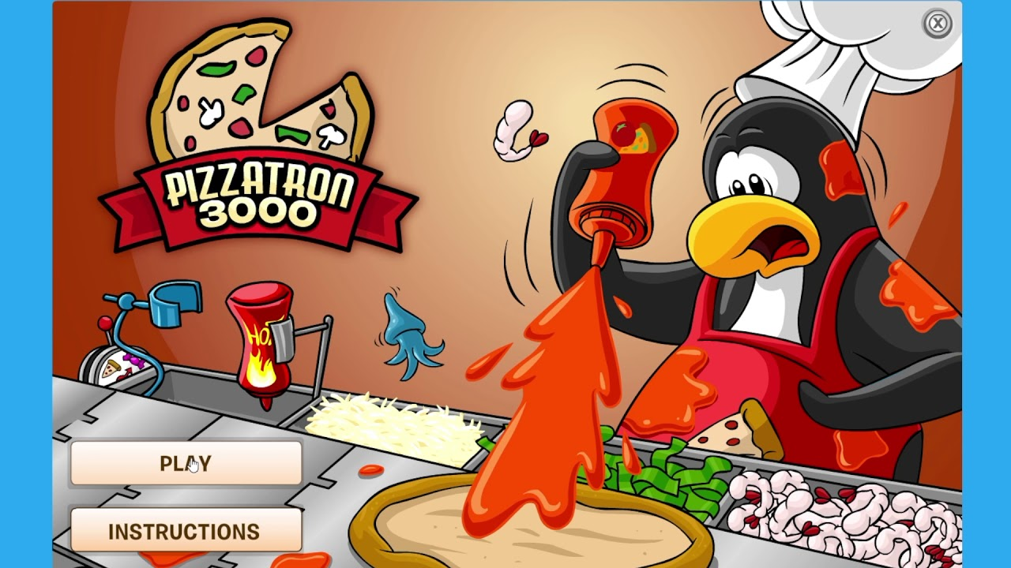

1. Zhicheng

* **Instruction Screen/Pop-Up:** ADR-> walk-through tutorial or static page of directions

1. Peter
2. Eric

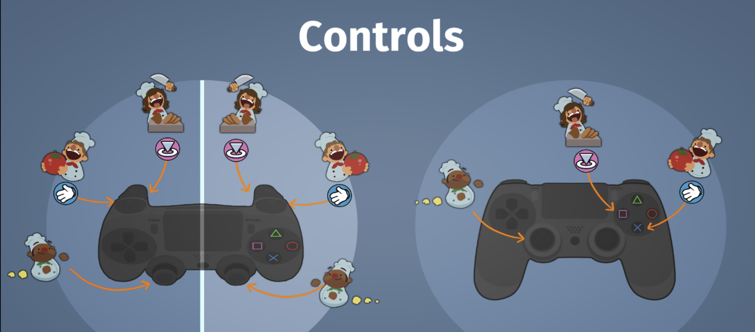

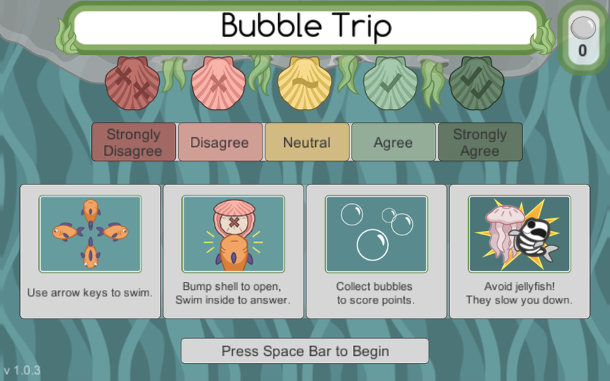

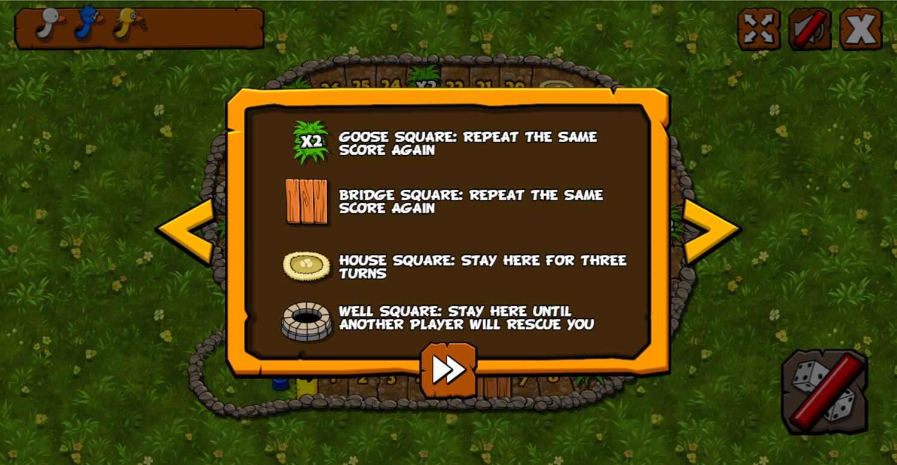

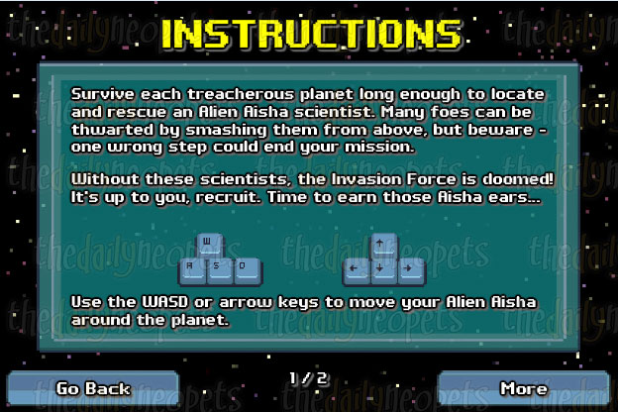

* **Food Selection/Order Screen:**

1. Richard
2. Georgio

ADR: click, or dag and drop, pizza-making animation of picking foods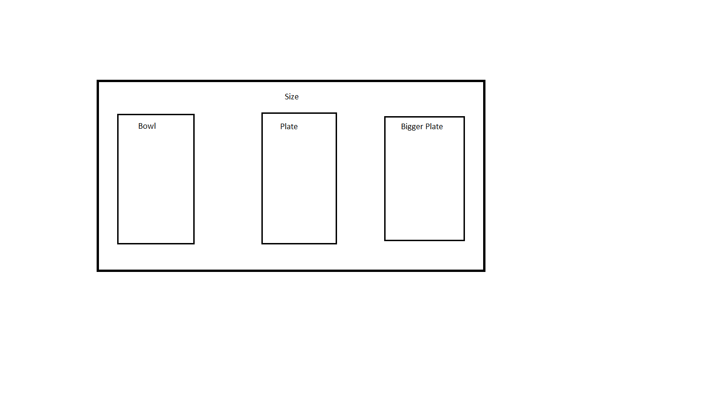

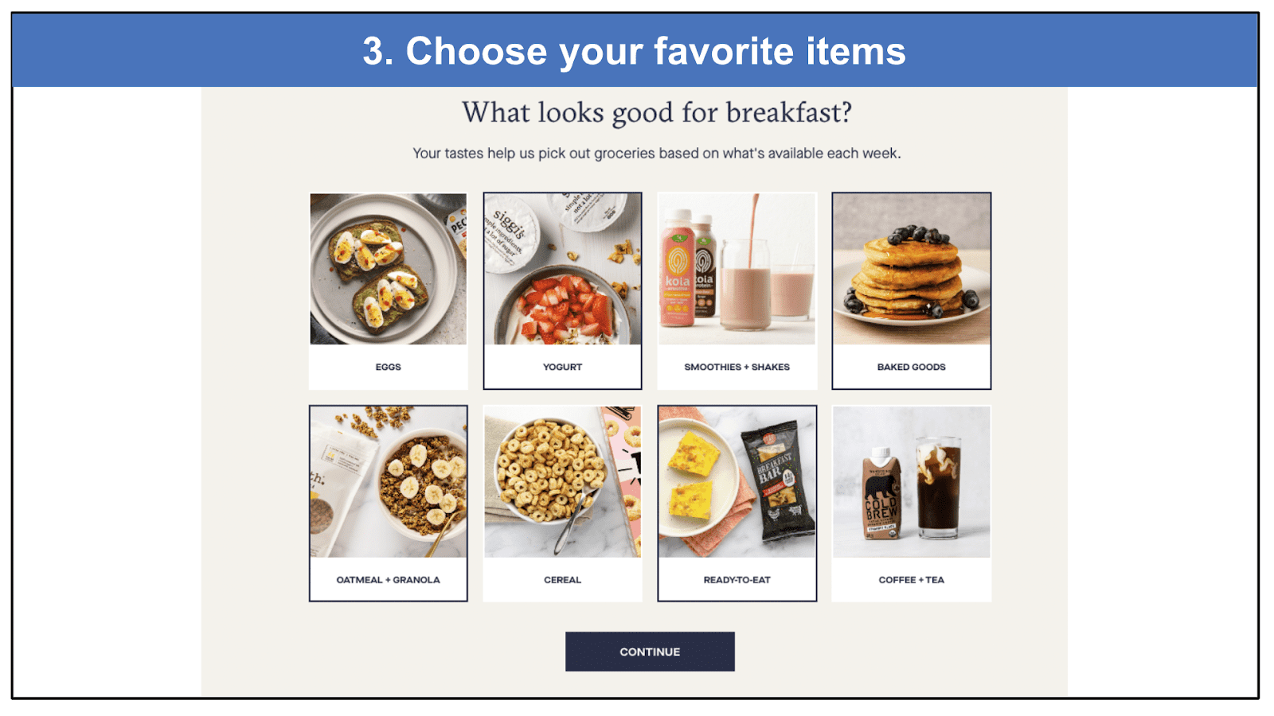

* **Fortune Cookie Animation Screen:**

1. Min

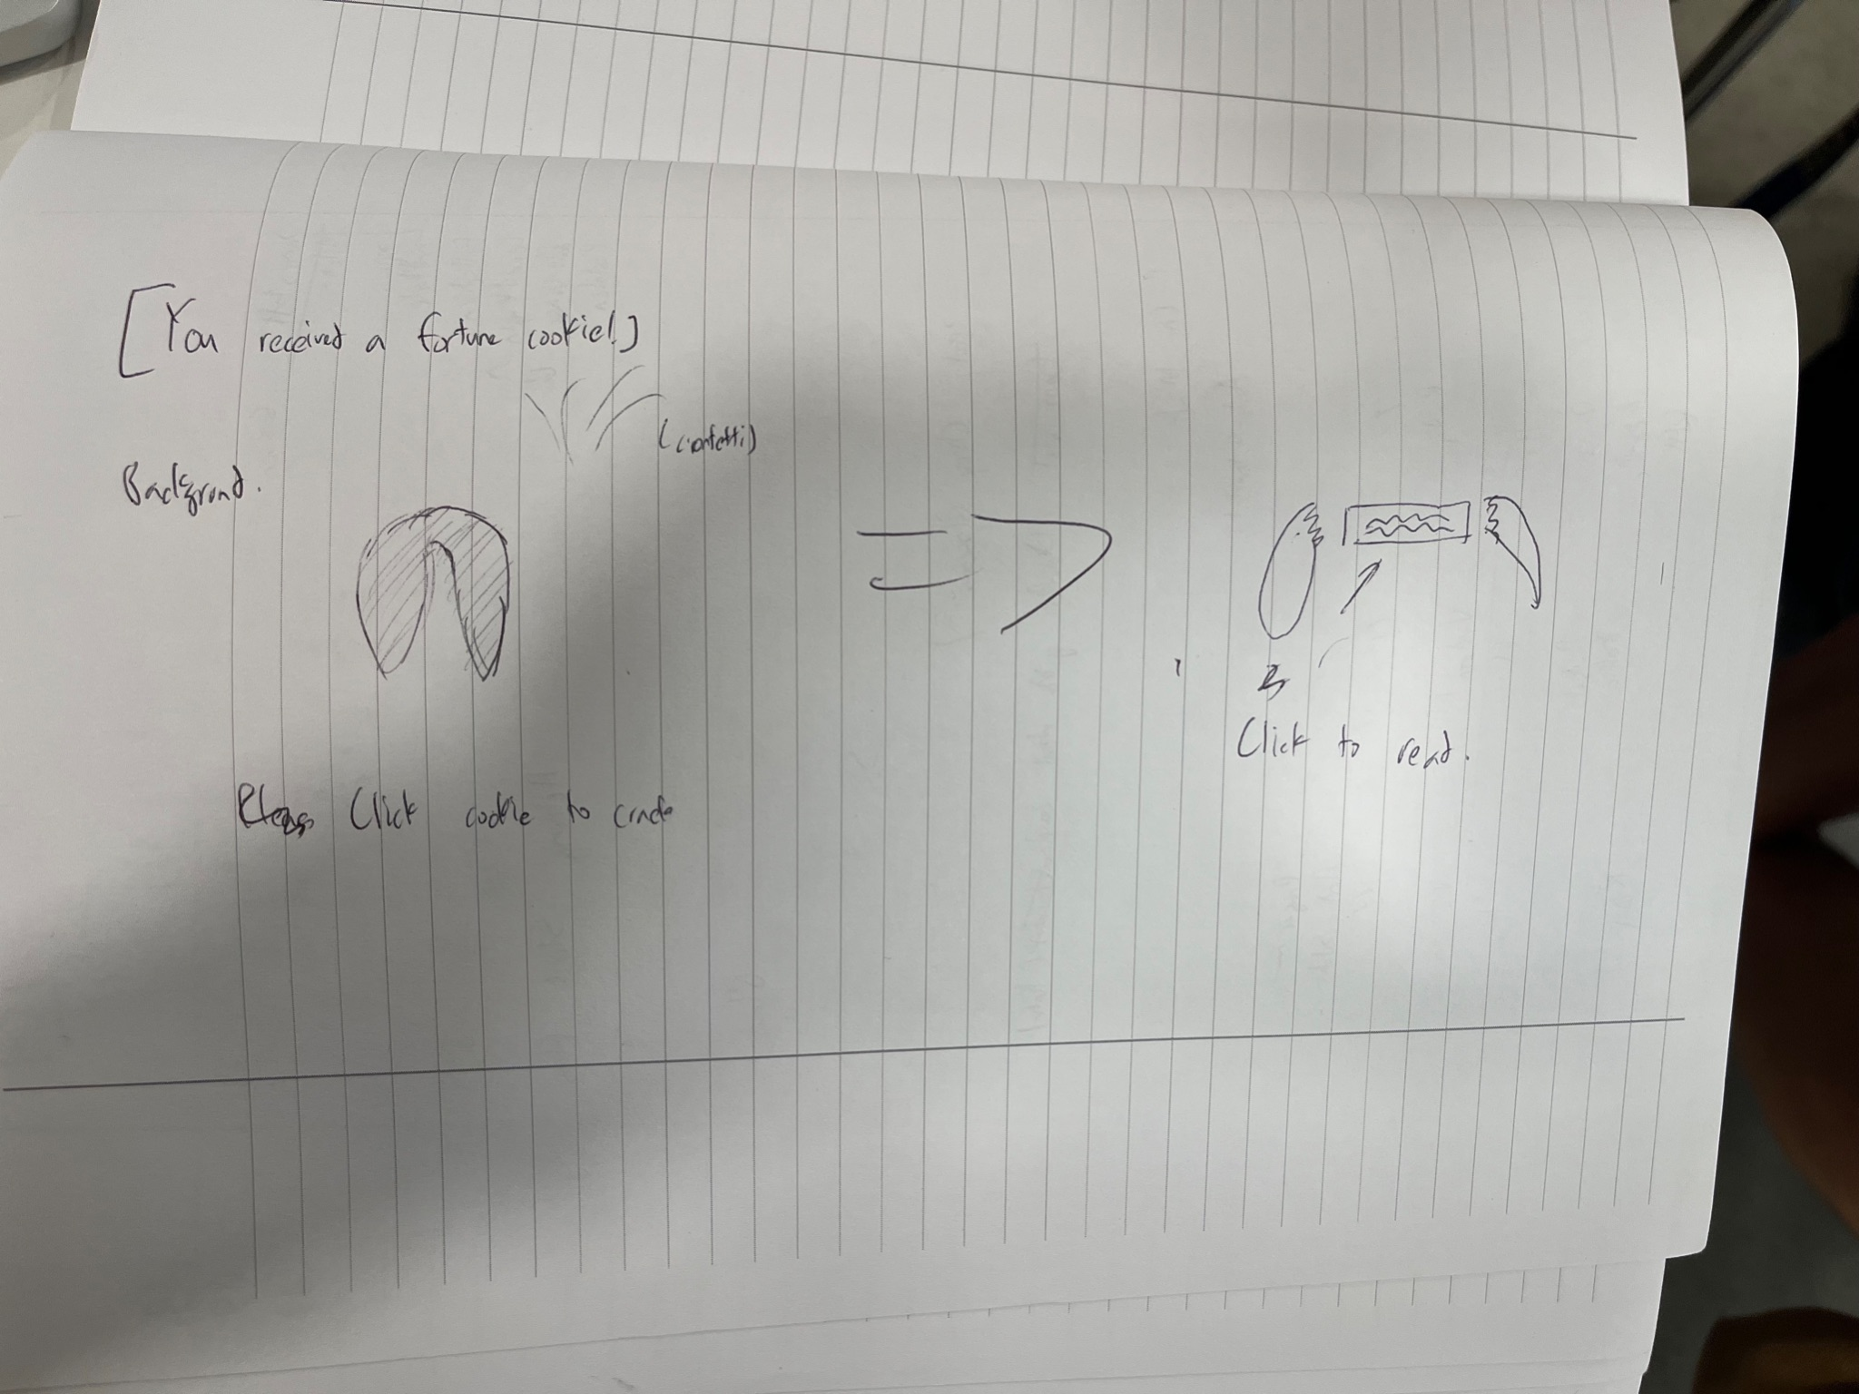

ADR: One click or multiple click to crack the fortune cookie? Gradual crack animation?

Click or drag to zoom fortune cookie message?

1. Chris

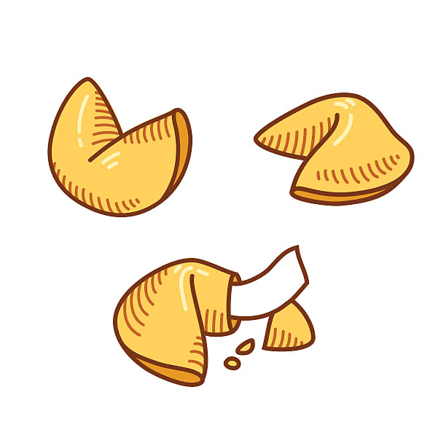

* **Loading Screen/Restart Game Pop-Up:**

1. Ryan

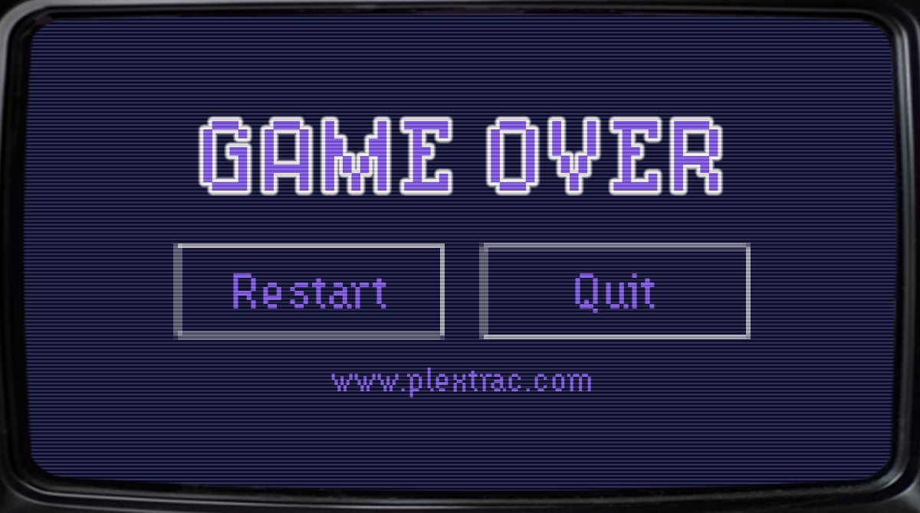

OR

ADR: pop up or new screen? Loading screen or not

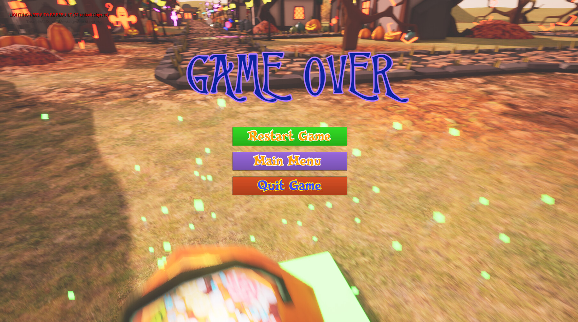

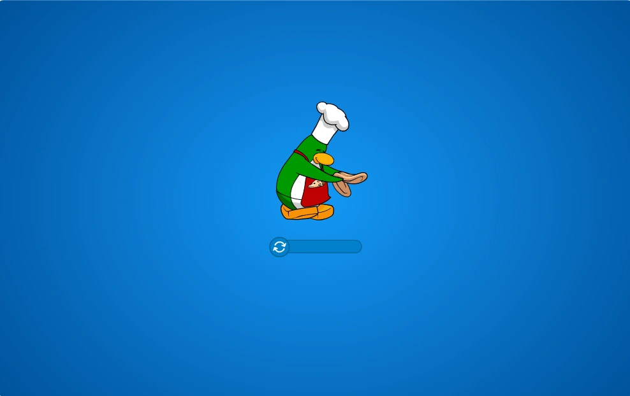

1. Zihan

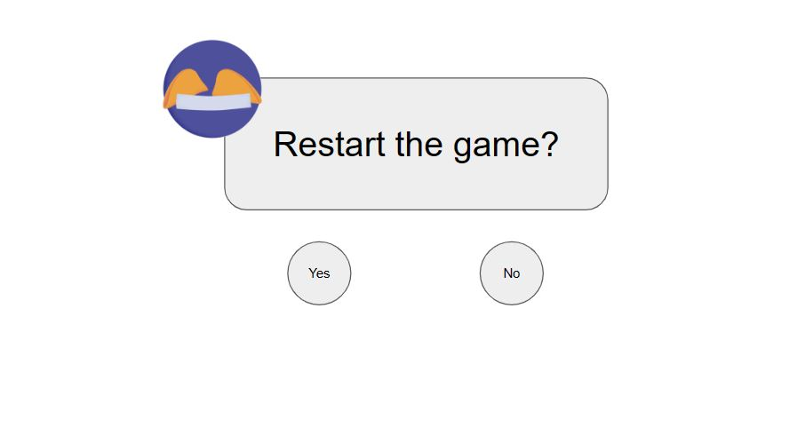

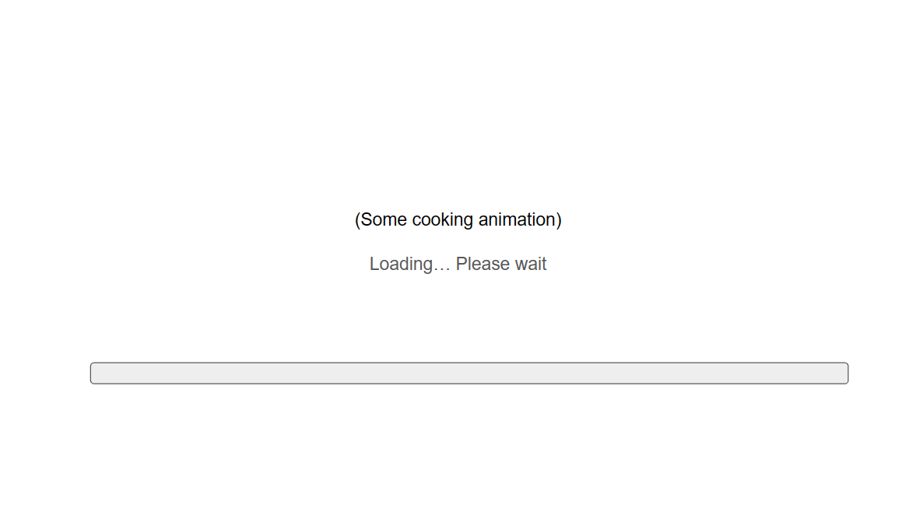



Context:

Our team has been tasked with designing the home screen of our new app, and the decision has been made that it should be inspired by the popular children's game, Club Penguin. The next step is to decide whether we should opt for a simplistic or complex design.

Decision:

After careful consideration, the team has decided to go with a simplistic design for the home screen. The Club Penguin game is known for its bright colors, cute characters, and simple gameplay mechanics. A complex design might not be in line with the game's overall aesthetic and could confuse young users who are our primary target audience.

Reasoning:

By keeping the home screen design simplistic, we can create a clean and easy-to-use interface that aligns with the game's overall feel. It will allow users to navigate the app easily and make it easier for them to understand what each button or section represents. Additionally, a simple design is more likely to load quickly, which is important for users who may have slower devices or connections.

Alternatives Considered:

We considered a complex design, which could have included a variety of different buttons, graphics, and animations. However, we ultimately decided that this could overwhelm users and detract from the app's overall purpose. While a more complex design might be more visually impressive, it could ultimately make it harder for users to access the content they need.

Consequences:

By choosing a simplistic design for the home screen, we anticipate that users will be able to navigate the app more easily, which should lead to a better overall user experience. Additionally, a simple design may be easier and less expensive to develop than a more complex one. However, some users may find the design too basic and may prefer a more visually stimulating layout.

Conclusion:

In conclusion, the team has decided to design the home screen of our new app with a simplistic design inspired by Club Penguin. While this decision may not appeal to all users, we believe it will be the best option for our primary target audience and will provide a clean and easy-to-use interface that aligns with the overall feel of the game.